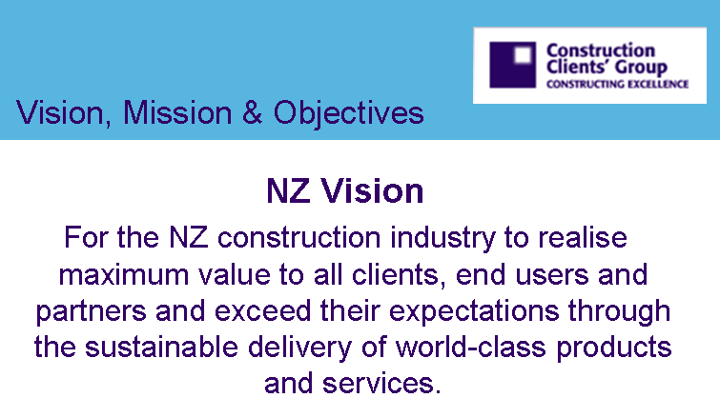
CCG Development Meeting

Meeting No. 12

24th August 2006

Dear all,

Thank you for your contributions to the twelth CCG meeting on 24 August & thank you to Duncan who was our host at Manukau City Council.

The meeting was attended by the following:

Joe Hollander | (Chair) Director Strategic Facilities Management | Massey University
Peter Burgess | Manager, Project Management Services | BECA
Benjamin Eitelberg | Project Manager | ANZ National Bank
Michael Griffiths | Group Manager, Projects and Maintenance Services | North Shore City Council
Simon Guillemin | Manager –Strategic Projects | North Shore City Council
Jane Henley | Chief Executive | New Zealand Green Building Council
Stephen Hunt | Manager Best Practice - Organisational Performance | Manukau City Council
Yadeed Lobo | Student Researcher | University of Auckland / Auckland Uniservices
Megan Renfree | (Secretariat) Executive Assistant | Naylor Love
Duncan Stuart | Project and Contracts Performance Manager | Manukau City Council
Adam Tyrie | Engineering Manager Buildings | Auckland International Airport Ltd
Chris Wood | Senior Adviser, Sustainable Industry and Climate Change, Govt3 | Ministry for the Environment
Stuart Wheeler | Principal Architect | Opus Consulting Engineers
Peter Fehl | Director, Property Services | University of Auckland

1. Meeting Outputs

Joe Hollander opened the meeting thanking Duncan for hosting the meeting at Manukau City Council and had a recap from last months meeting:

- ANZ and AIAL will adopt the Project Charter for their next project. Manukau City Council will adopt the Company Charter overall. Massey University will adopt the Project Charter for their Library Project in Albany. Peter Fehl advised he was happy to look at the charter and review it for Auckland University.
- Most of the client group has signed up for the Benchmarking Charter and will aim to use this on a minimum of 1 project next year.
- We are still looking for some more hosts for meetings for the ten sessions in 2007. A programme will be drawn up at the October meeting.
- September Meeting. Gail can now no longer attend the September meeting and is unable to host it. Opus will now host instead.
- A briefing session was held on 3 August in Wellington with a ministerial panel. Amanda gave a good presentation on the CCG and KPI’s. Other attendees included Ian Wheeler, People from the Ministry of Economic Development, Peter Nevan from Fletchers, the CEO from Fulton Hogan. John Phalert from the CIC will commit to looking at this in another 6 months time (eg. March 2007)
- Encourage Client members to contribute funding to the group of $1000 a year to cover all administration expenses.
- Programme for next years meetings will be scheduled at the October meeting. If there are any issues or topics wanted please contact Joe or Amanda.
- Don Ward visit, hosted by IPENZ and ICE on 4 September at 6:00pm. Drinks and nibbles
- Pathfinder projects – need to get a couple of these going for 2007
- CCG to look at expanding to other centres, eg. Wellington and South Island in 2007.

CURRENT STATE OF SUSTAINABILITY IN NEW ZEALAND
Presentation by Jane Henley, CEO, NZ Green Building Council (www.nzgbc.org.nz)

Jane gave a presentation on the current state of sustainability:

- Overview
  - About the NZGBC
  - The current state of play
  - Building Assessment Systems
  - NZ’s adaptation
  - Case Study
  - Where is there opportunity for you?
  - What next….

- The Vision

To use market- driven solutions to bring New Zealand’s Building and Construction industry to the forefront World’s Best Practice and beyond. Ensuring that we live and work in the healthiest, most efficient, productive buildings today and into the future.

NZGBC MISSION
To facilitate the transformation of the industry through education, tools, and knowledge sharing to reduce impact of building development & use

- Why
  - Because we are in a position of influence
  - 40 to 50% of the world’s energy is used in buildings
  - 25% of the waste in New Zealand’s landfills was produced by the building industry.
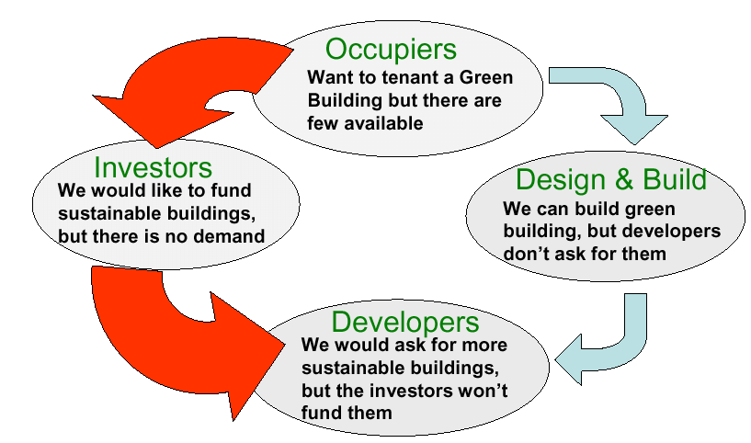
  - We spend 95% of our time in buildings

- Why (Clients)
  - ability to attract and retain staff
  - healthy productive environment
  - anticipating the new market
  - future proofing
  - long term investment value
  - Reduction in operating costs

- Our Focus
  - Building Assessment Systems
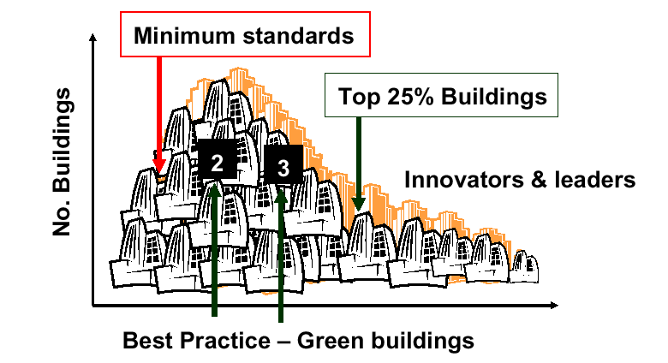

  - Education & Training
  - Information and Resources

- Who are we?
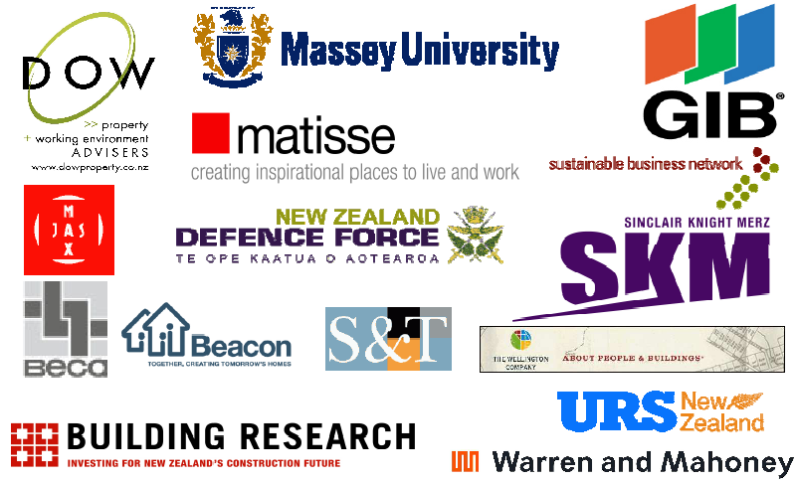
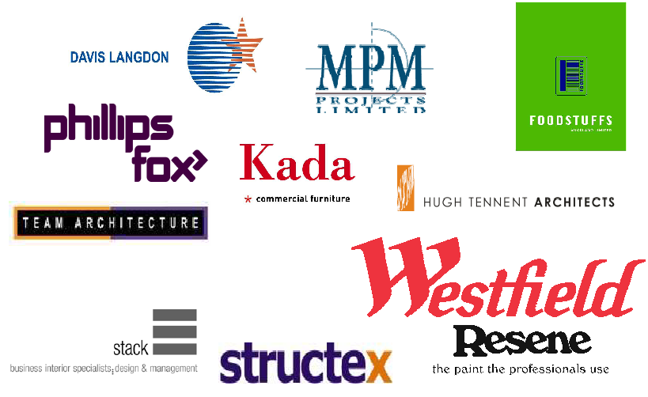

- What Next?
  - Rating Tool development- 2006
  - Partnerships
  - Alignment with Govt 3
  - Product rating
  - Informing & providing practical resources
  - Education of whole building value chain

The full PDF of the presentation can be downloaded from the CCG website. ?

A discussion followed the presentation on the benefits of the Green Building Council and on the current case study, the Meridian Building in Wellington, which is an Environmental sustainable design and is aiming to get a 4 star certification from the NZGBC.
Points brought up from the discussion were:
- Companies need to have a separate ESD budget
- NZ currently has low energy costs and low water costs. What about in the future? Could this outweigh the extra costs at the design/build stage.
- Companies need to benchmark the construction cost throughout the process

THE WAIATARUA WETLANDS
Presentation by Peter Burgess from BECA, the winners of the Arthur Mead Environmental Award 2006

Peter gave a presentation on BECA’s award winning project and on the process it took to create the wetland’s that is there today.

Purpose
- This award winning project was designed to solve the problem of deteriorating water quality in the Orakei Basin and the Waitemata Harbour.
- To remove more than 80 per cent of contaminants in the stormwater run-off, which passes through the reserve (wetland) in Remuera.

Scope
- Stage 2 - planting native trees to provide year-round feed for birds, constructing new pathways and extending the network of weirs, drains and sediment traps built in stage one.
- Stage 3 – transformation of the centre of the reserve from a boggy swamp into a beautiful wetland, featuring viewing platforms, boardwalks, seating and educational signs.

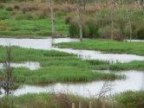 | 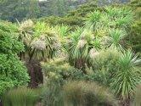 | 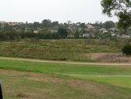
Open Wetland Waterways | Buffer Zone | Flood Plain

- Where is the Wetlands
  - Issues addressed by project
    - Flooding
    - Pollution

- Innovative Solutions
  - Treatment train specific to site features
  - Treatment train incorporates flood management
  - Combined consultants/stakeholders design team

- Sustainability
  - O&M Plan
  - 3 Stage treatment train easy to maintain
  - Wetland (Sediment, Planting)

- Consultation
  - Benefits
    - Ecosystem
    - Water (Zinc, Copper, Algal Bloom)
    - Amenities

SUSTAINABILITY AND HOW IT RELATES TO THE CLIENTS & BENCHMARKING CHARTER

Joe initiated a discussion with the group about sustainability and how it relates to the clients and the benchmarking charter.
Yadeed provided an overview on EMS and related initiatives.
A number of initiatives are going on at the moment that back up all of the benefits of sustainability and change that is going to impact on us in the future. These include the NZ Urban Design Protocol, CPTED, C&D Waste (Zero Waste), Energy Mngt, OH & S, Govt 3, etc.

DEMAND QUALITY WATERSHED
OF LIFE

All the initiatives are moving in the right direct and it is a good time to get together you’re your management teams and start floating the information by them to convince them it will eventually catch up with them in form of compliance through legislative change, etc.

The group discussed how we can meet these challenges, how we can explain what sustainability is and who do we benchmark it with ? Currently organisations with standards in Sustainability are:

- ISO 14000 Certification. This is like the ISO9000 certification and has different levels;
- EMS - Four standards to help companies become ISO accredited;
- MED Sustainability Cluster and Council for Sustainable Business (www.sustainable.org.nz)
Discussion also considered “Environmental Choice” baselines for comparison and “triple bottom line” reporting (with Social being “Health”. Also the need for LCA and WOLCC considerations built into project design and scoping work.

GOVT³ AND SUSTAINABLE BUILDING IN NEW ZEALAND
Chris Wood, Senior Adviser, Sustainable Industry and Climate Change, Govt3, Ministry for the Environment

Chris spoke about the governments involvement in sustainable building in New Zealand.

- Why sustainable buildings?
  - 40% of all energy consumption (OECD) contribute 50% waste
  - consumes 1/4 of all the wood harvested in the world
  - produce 35% of greenhouses gases CO2 (OECD)
  - consume 40% of raw materials use globally (3 billion tons annually)

- Why sustainable public buildings?
  - Government procurement
    - Government staff work in buildings (17,480 in Wellington alone)
    - Government is a major player in New Zealand construction sector (estimated at >30%)
    - Ability to influence the commercial building sector

- Govt 3
  - Formed in 2003
  - Cabinet requirement March 2006
    - Ministers remind departments and agencies that it is the government’s expectation that all core public service agencies will participate in the Govt 3 initiative.
  - Engagement – influence – action
  - 47 agencies signed up
  - Agencies annual procurement budget - 25 Billion
  - Will move into Local Government in the near future
  - Focuses support in 4 areas:
    - Vehicles
    - Waste
    - Office consumables and equipment
    - Buildings

What is a sustainable building?

Sustainable Buildings are designed and constructed to the highest environmental standards, (especially in order to minimise the use of energy, water and scarce minerals/timber), that are economic to run over their whole lifetime and are sufficiently flexible to meet the needs of future generations. Nottinghamshire County Council

Buildings are ”sustainable” when they are designed, built and operated with low environmental impacts (or actually starts to have a positive environmental impact) while enhancing the health, welfare and quality of life of the people that live and work in them. Variation on that used by British Columbia’s Sustainable Building Centre.

- What is a sustainable building? Consider:
  - Energy efficiency
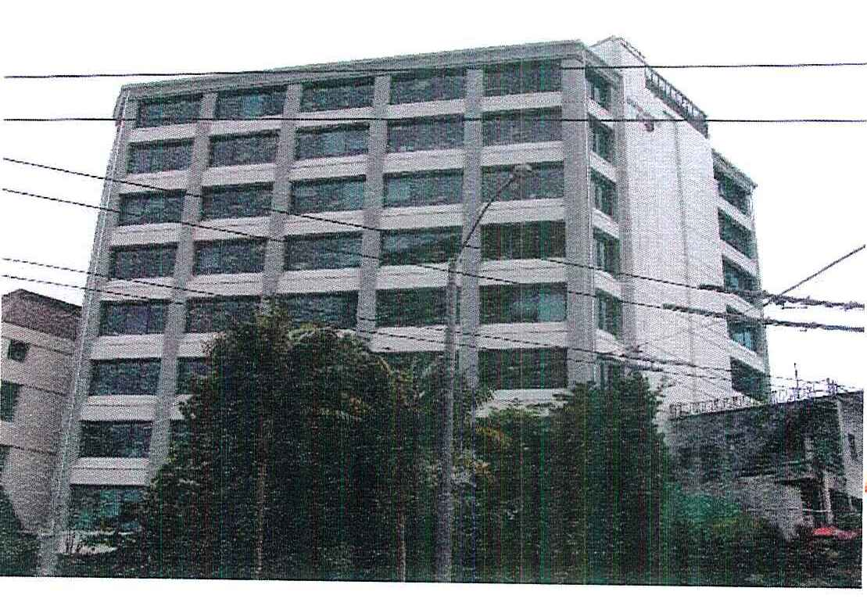
  - Water conservation
  - Indoor environmental quality
  - Materials
  - Ecology of the site
  - Waste minimisation
  - Transport

- My work programme
  - One on ones with agencies
  - Build the economic environmental and
social case
  - Case studies
  - Link people up
  - Workshops
  - Rating Tools
  - RFP & other contract documents
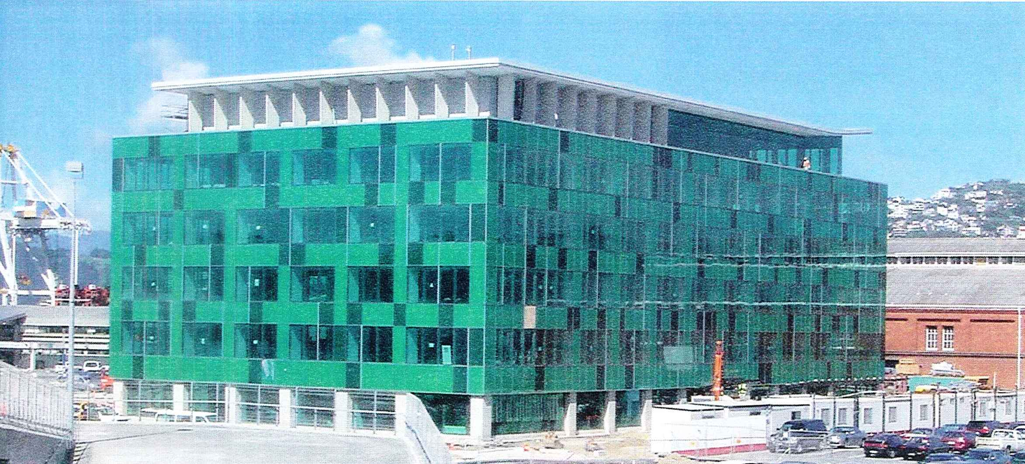
- Case Study - Environment House
  - 40% energy usage –saves $100,000 annually
  - 26% decrease on 2003/2004 CO2 emissions
  - Increase in the number of people cycling
  - 22% decrease in waste to landfill
  - Experiences to share with others

- Case Study - Statistics NZ
  - Double glazing
  - Energy efficient lighting & HVAC systems
  - Above building code levels of insulation
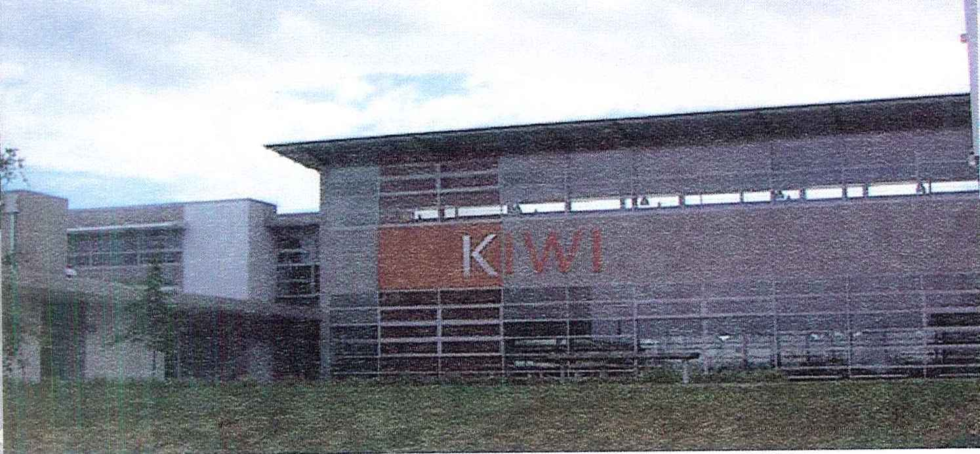
  - Central stair case

- Case Study – Albany Junior High School
  - Solar hot water units of Gym
  - Some roofs oriented for photovoltaics
  - Under floor heating

- Productivity

  - 5 - 15% increases in productivity measured internationally
  - Less sick leave, and absenteeism and increased length of tenure
  - Greater user satisfaction
  - PROBE studies show NZ ‘green buildings’ in top 5% in world.
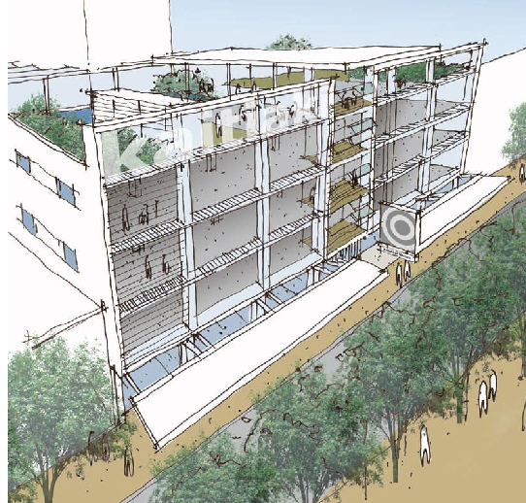
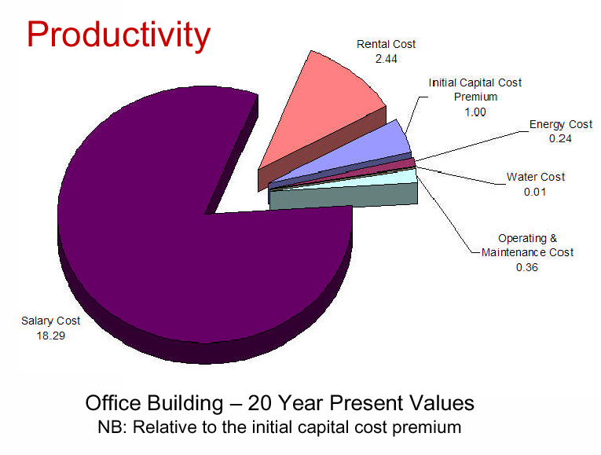
- Current Sustainable Project – DoC Head Office

  - Atria for natural day-lighting and ventilation
  - Double skin facades to main street frontages
  - Heating and cooling supply by existing
  - chillers and new heat pumps
  - Energy efficient lighting and controls
  - Solar and heat pump hot water system
  - Energy management system

- Energy/Design Rates

  - Optimum design target is 58 to 80 KWh/m² for office space
  - MfE offices currently at 113 KWh/m²

HOW CAN THE CCG DO MORE?

FOSTER COMMITMENT TO SUSTAIABILITY

HOMEWORK

The group decided to do a Electrical Consumption Experiment out of general interest.

Please calculate your electrical consumption for your office for the next meeting by dividing the Kh/hr amount on your power bill by the total square metres of your office.

Ecological Footprint Calculator: http://www.mfe.govt.nz/withyou/do/footprint/calculator.html

5. Future Meetings

Future meeting dates so far are:

- September 21st – Host: Inland Revenue, Theme: Delivery vehicles & contract options: Alliancing vs partnering etc
- October 19th – Host: Opus International Consultants, Theme: Lean Construction & Last Planner - CANCELLED
- November 23rd – Host: Ministry of Education, Theme: UK Study Tour Findings & Annual Review

6. Conclusion
- Thanks to Duncan and Manukau City Council for hosting, excellent venue, catering and support.
- Thanks also to Yadeed for standing in for Amanda and assisting with session admin.
- Also to Megan Renfree from Naylor Love for recording, reporting and helping Yadeed.
- Reminder to all about funding, hosting, Pathfinder topics, Benchmarking etc.

